# What a weird keyboard! (Cryptography)

Again, many solves on this challenge.

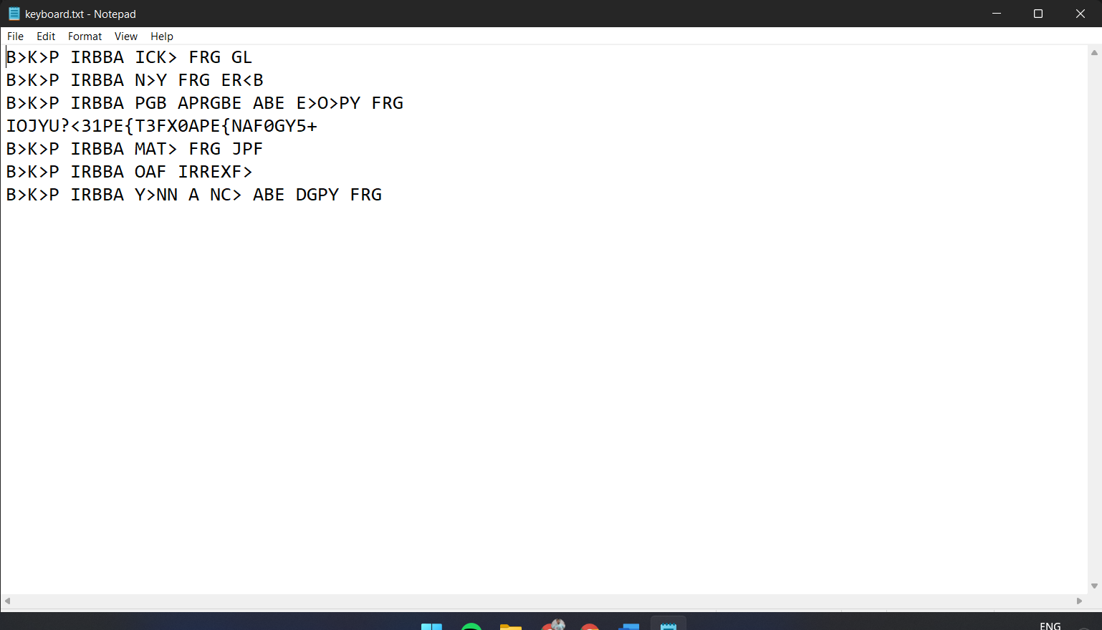

This is a keyboard change cipher. The ciphertext is in Dvorak and just putting in a Dvorak to QWERTY convertor will give the flag (along with a cheeky rickroll 😉)

